**Proposal design for Hotspot set up in coffee shop**

A COURSE PROJECT REPORT

# ABSTRACT

A coffee shop needs to setup with a hotspot, where users can access ADSL internet through wireless network with a prepaid card.

Asymmetric digital subscriber line(ADSL) is a technology that facilitates fast data transmission at a high bandwidth on existing copper wire telephone lines to homes and businesses

# ACKNOWLEDGEMENT

We express our heartfelt thanks to our honorable **Vice Chancellor Dr. C. MUTHAMIZHCHELVAN**, for being the beacon in all ourendeavors.

We would like to express my warmth of gratitude to our **Registrar Dr. S. Ponnusamy,** for his encouragement

We express our profound gratitude to our **Dean (College of Engineering and Technology) Dr. T. V.Gopal,** for bringing out novelty in all executions.

We would like to express my heartfelt thanks to Chairperson, School of Computing **Dr. Revathi Venkataraman,** for imparting confidence to complete my courseproject

We wish to express my sincere thanks to **Course Audit Professor Dr.Annapurani Panaiyappan, Professor and Head, Department of Networking and Communications**and **Course Coordinators**for their constant encouragement andsupport.

We are highly thankful to our my Course project Faculty **Mahalakshmi.P**

**Assistant Professor Networking and Communication SRM Institute of Science and Technology** for his/herassistance, timely suggestion and guidance throughout the duration of this course project.

We extend my gratitude to our **HoD** **Dr.Annapurani Panaiyappan, Professor and Head, Department of Networking and Communications** and my Departmental colleagues for theirSupport.

Finally, we thank our parents and friends near and dear ones who directly and indirectly contributed to the successful completion of our project. Above all, I thank the almighty for showering his blessings on me to complete my Courseproject.

**TABLE OF CONTENTS**

## CHAPTERS CONTENTS PAGENO.

* + - 1. **ABSTRACT**
      2. **INTRODUCTION**
      3. **LITERATURE SURVEY**
      4. **REQUIREMENTANALYSIS**
      5. **ARCHITECTURE &DESIGN**
      6. **IMPLEMENTATION**
      7. **EXPERIMENT RESULTS &ANALYSIS**
         1. RESULTS
         2. RESULTANALYSIS
      8. **CONCLUSION & FUTURE ENHANCEMENT**
      9. **REFERENCES**

1. **INTRODUCTION**
   1. **Scenario Description**
2. **LITERATURE SURVEY**

1.1 ADSL Technology

|  |  |
| --- | --- |
| Research Article Name | ADSL TECHNOLOGY |
| Problems Addressed/Identified | VPN and router/firewall security, Asymmetrical speeds |
| Objectives | The paper deals with the ADSL (Asymmetric Digital Subscriber Line) technology- the asymmetric digital telecommunication technology |
| Novelty/Significance | influences data transmission via telephone network |
| Limitations/Disadvantages | Data protection, Possible bottlenecks and low speeds |
| Implementation  Details/Experimental Setup | ADSL runs on Telkom's copper line network. In order to install ADSL, you will need to have a normal Telkom voice line installed. ADSL runs over the normal voice line. |
| Findings/Conclusions | The quality of the service is significant compared to what consumers pay |

1.2 Wireless Hotspots: Current Challenges and Future Directions

|  |  |
| --- | --- |
| Research Article Name | Wireless Hotspots: Current Challenges and Future  Directions |
| Problems Addressed/Identified | Authentication, security, coverage, management, location services, billing, and interoperability. |
| Objectives | Highlight the challenges posed by the vision of a global hotspot infrastructure |
| Novelty/Significance | Introducing the concept of NGH - Next Generation Hotspot - enables mobile subscriber or user to connect automatically and securely to hotspots |
| Limitations/Disadvantages | Security Challenges - Evil Twin Attack, Session Hijacking, Eavesdropping |
| Implementation  Details/Experimental Setup | NGH - Use of Mobile Credentials stored in SIM Card in the handset - can be easily removed and be used between various devices. |
| Findings/Conclusions | Brought to light the various problems with regard to the performance benefits of WLANs that they are not perfectly suited platform for networking in public places along with the solution - NGH |

1.3 Consumers perception on prepaid cards

|  |  |
| --- | --- |
| Research Article Name | Consumers perception on prepaid cards |
| Problems  Addressed/Identified | Internet broadcasting, Networking standards, Allowed range of communication, lack of equipment, Security issues. |
| Objectives | Setting up a large Internet Community through Wi-Fi hotspots from internet cards. |
| Novelty/Significance | Helpful for travelers; Avoids credit problems; Control on internet usage. |
| Limitations/Disadvantages | Slow on phone line connection; Expensive when used outside the zone; One has to buy another card when time runs out; Undisclosed fees imposed by the issuers. |
| Implementation  Details/Experimental Setup | Some computers and PCs come with pre-installed wireless adapter card whereas in some of the PCs USB ports are used to connect to prepaid cards. Another option is to use WCF (Wireless Compact Flash) cards which fit into the slots on the sides of PC. |
| Findings/Conclusions | It is necessary to check the reliability and compatibility of the cards before purchasing and also if it meets our data requirements. Prepaid cards are gradually being accepted by general public. |

1.4 Wireless Broadband Network Technology Infrastructure and Related Intellectual Property Application & Security

|  |  |
| --- | --- |
| Research Article Name | Wireless Broadband Network Technology Infrastructure and Related Intellectual Property Application & Security |
| Problems Addressed/Identified | * Network access control, * Network resource protection, * End-point, including wireless client, protection, * Secure end-to-end data traffic transmission, * Secure network configuration, operation and management |
| Objectives | Examined the fixed and mobile broadband wireless networks and provides a comparative view of both types. |
| Novelty/Significance | 1.Benefits of Wireless Broadband Outdoor, field operations: Disaster Recovery, Battlefields  2. Home banking, Interactive Gaming sites |
| Limitations/Disadvantages | Distance Limitations - they vary with frequency band, technology and vendor implementation. performance or throughput may become lower with distance because of signal strength |
| Implementation  Details/Experimental Setup | Security Architecture for Mobile WAP-based Devices - makes use of Compression Encryption UDP Protocol, Secure Socket Layer, and Firewall |
| Findings/Conclusions | Explored the problems at the implementation level of the current wireless access technologies and their real-world implications. |

1. **REQUIREMENTS**
   1. **Requirement Analysis**

Users should be able to access internet through prepaid card, which can be purchased from the coffee shops.

The employees should be able to access the internet without passwords.

A hotspot management system, internet sharing mechanism, access point integration, IP address management and seamless access to internet for employees needs to be identified.

A network topology listing all the components should be included.

Networking Components and features with explanation on integration plan.

Hardware inventory list.

* 1. **System Requirement**
* **CPU: 3 gigahertz (GHz) or faster 64-bit (x64) processor**
* **RAM: 4 gigabyte (GB)**
* **NIC: 2 PCI network interface cards, for maximum performance we recommend using Intel PRO/1000 (EXPI9400PTBLK) network adapters**
* **OS: Windows Server 2008, Server 2012, Server 2016, Windows 7, Windows 8.1, Windows 10.**
* **We recommend Windows Server OS 2016 with DHCP and RRAS roles configured within OS.**

1. **ARCHITECTURE AND DESIGN**
   1. **Network Architecture**

The network architecture is as follows:

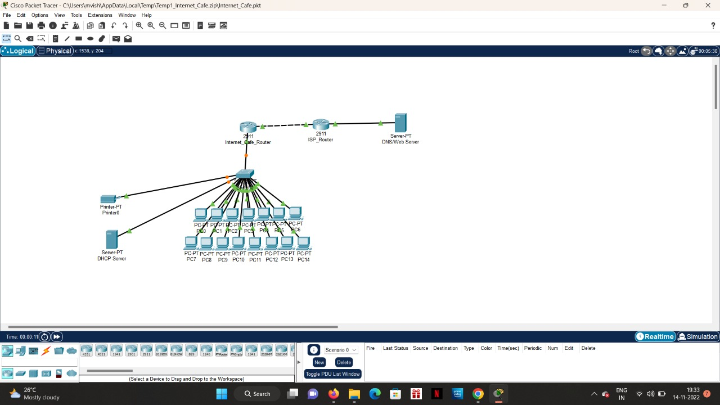

The architecture consists of three major networks:

* Company Network(s)
* Public Internet
* Network maintained by the Internet Service Provider

These networks are interconnected with each other with varying degrees (discussed in the implementation chapter).

1. **IMPLEMENTATION**
   1. **Address Table**

The address table is as follows:

|  |  |  |
| --- | --- | --- |
| **Device** | **Interface** | **Address** |
| Server | Fa0 | 172.16.0.2 |
| Company Router | Fa0/0 | 172.16.0.1 |
| Fa1/0 | 192.16.0.1 |
| Se2/0 | 10.0.0.1 |
| Employee PC | Fa0/0 | 192.16.0.2 to 192.16.0.7 |
| Broadband Router | Se2/0 | 10.0.0.2 |
| Fa0/0 | 192.168.10.1 |
| Public PC | Fa0/0 | 192.168.10.2 to 192.168.10.4 |

The Company Router has NAT configured with an ACL.

The Access Control List contains the entire broadband network. Any request from that network is translated to the private IP of the server.

Static Routing is used on all the routers to interconnect the networks.

1. **RESULTS AND DISCUSSION**
   1. **Connection Check**

The network connections were checked by ping requests:

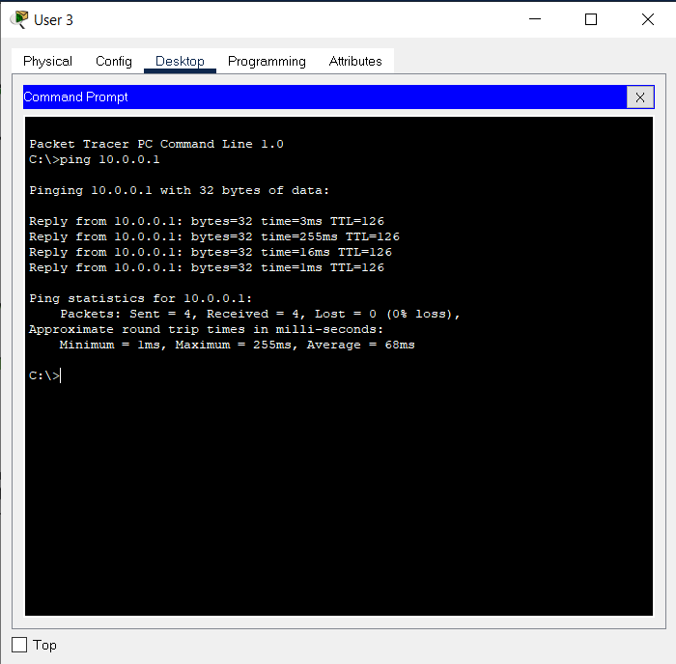

A public PC pinging the server via public IP

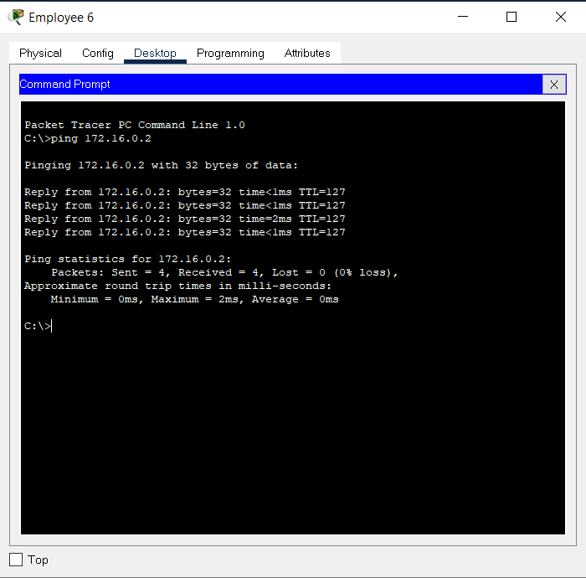

An employee PC pinging the server via private IP

* 1. **HTTPS Check**

The server access was checked with HTTPS by using a browser:

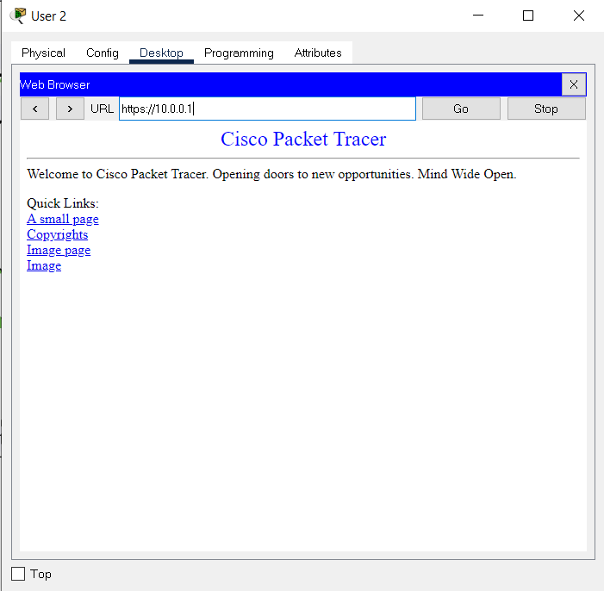

1. **CONCLUSION AND FUTURE ENHANCEMENT**

**REFERENCES**

https://www.researchgate.net/publication/221204686_Wireless_Hotspots_Current_Challenges_and_Future_Directions

https://www.researchgate.net/publication/267385109_Consumers_Perception_on_Prepaid_Cards_Survey_and_Analysis

https://www.researchgate.net/publication/221204686_Wireless_Hotspots_Current_Challenges_and_Future_Directions